IBM Highly Available Cluster Multiprocessing for AIX (HACMP6.1)

IBM Highly Available Cluster Multiprocessing for AIX, (HACMP) provides the ability to keep business-critical applications and systems operational 7 days per week, 24 hours per day. An HACMP solution helps avoid downtime, enables prompt recovery from any hardware, network and application failures, and also gives you the means to take down an individual server (node) for planned maintenance and upgrades without having to take down the entire cluster.

Cluster Name: adminserv_cluster

Cluster Connection Authentication Mode: Standard

Cluster Message Authentication Mode: None

Cluster Message Encryption: None

Use Persistent Labels for Communication: No

## HACMP Nodes and Networks Configure Planning

General network connection consideration: An example of correct HACMP networking consists of two separate Ethernet networks, each with two network interfaces on each node. Two routers connect the networks, and route packets between the cluster and clients, but not between the two networks.

There are 2 node(s) defined

net_ether_01

**en0:** admsrv2_bt1 192.168.101.211

admsrv2_pip 192.168.104.212

**en0:** admsrv1_bt1 192.168.101.201

admsrv1_pip 192.168.104.202

**en1:** admsrv2_bt2 192.168.102.214

admsrv2_svc 192.168.104.213

**en1:** admsrv1_bt2 192.168.102.204

admsrv1_svc 192.168.104.203

Node: admsrv1

HACMP Version:6.1.0

Resource Group: imaging_RG

Participating Nodes admsrv1 admsrv2

Service IP Label admsrv1_svc

Application Server imging_app

Node: admsrv2

HACMP Version:6.1.0

Resource Group: tsm_RG

Participating Nodes admsrv2 admsrv1

Service IP Label admsrv2_svc

Application Server tsm_app

hdisk2

net_diskhb_01

**en2:** admsrv1 192.168.103.211

**en2:** admsrv2 192.168.103.212

To avoid cluster partitioning, 2 networks, One TCPIP Network: net_ether_01, one Non-IP Network: netdiskhb_01.

|  |  |
| --- | --- |
| NODE admsrv1:  Network net_diskhb_01  admsrv1_hdisk2_01 /dev/hdisk2  Network net_ether_01  admsrv1_svc 192.168.104.203  admsrv2_svc 192.168.104.213  admsrv1_bt1 192.168.101.201  admsrv1_bt2 192.168.102.204 | NODE admsrv2:  Network net_diskhb_01  admsrv2_hdisk2_01 /dev/hdisk2  Network net_ether_01  admsrv1_svc 192.168.104.203  admsrv2_svc 192.168.104.213  admsrv2_bt1 192.168.101.211  admsrv2_bt2 192.168.102.214 |

Before using the Two-Node Cluster Configuration Assistant to configure an HACMP cluster definition, make sure that:

* The node running the Assistant has start and stop scripts for the application(s) to be made highly available.
* Both nodes have TCP/IP connectivity to each other.
* Both nodes are physically connected to all disks configured within the volume groups.
* Both nodes have the HACMP software and the same version of the RSCT software.
* Both nodes have a copy of the application that is to be highly available.
* The etc/hosts file on both nodes is configured with a service IP label/address to be specified in the Assistant.

Let’s start from Configure an HACMP Cluster - > Remove an HACMP Cluster if there is any cluster exist

## Prepare 2 basic network configuration/authorization files: *.rhosts and /etc/hosts*

root@admsrv1:/ # cat /.rhosts

*admsrv1 root*

*admsrv2 root*

*nimserver root*

root@admsrv1:/ # cat /etc/hosts

*# @(#)47 1.1 src/bos/usr/sbin/netstart/hosts, cmdnet, bos530 7/24/91 10:00:46*

*# IBM_PROLOG_BEGIN_TAG*

*# This is an automatically generated prolog.*

*#*

*# bos530 src/bos/usr/sbin/netstart/hosts 1.1*

*#*

*# Licensed Materials - Property of IBM*

*#*

*# Internet Address Hostname # Comments*

*# 192.9.200.1 net0sample # ethernet name/address*

*# 128.100.0.1 token0sample # token ring name/address*

*# 10.2.0.2 x25sample # x.25 name/address*

*127.0.0.1 loopback localhost # loopback (lo0) name/address*

*# Comunication Interfaces*

*192.168.104.201 admsrv1 admsrv1.livingstonintl.com #configure it on en0 of admsrv1 as alias*

*192.168.104.211 admsrv2 admsrv2.livingstonintl.com #configure it on en0 of admsrv2 as alias*

*# Management Interfaces*

*#192.168.103.211 admsrv1 admsrv1.livingstonintl.com*

*#192.168.103.212 admsrv2 admsrv2.livingstonintl.com*

*# HACMP ADMSRV1 Interfaces*

*192.168.101.201 admsrv1_bt1 admsrv1_bt1.livingstonintl.com #configure it on en0 of admsrv1*

*192.168.104.202 admsrv1_pip admsrv1_pip.livingstonintl.com*

*192.168.103.203 admsrv1_svc admsrv1_svc.livingstonintl.com adminserv*

*192.168.102.204 admsrv1_bt2 admsrv1_bt2.livingstonintl.com #configure it on en1of admsrv1*

*# HACMP ADMSRV2 Interfaces*

*192.168.101.211 admsrv2_bt1 admsrv2_bt1.livingstonintl.com #configure it on en0 of admsrv2*

*192.168.104.212 admsrv2_pip admsrv2_pip.livingstonintl.com*

*192.168.103.213 admsrv2_svc admsrv2_svc.livingstonintl.com*

*192.168.102.214 admsrv2_bt2 admsrv2_bt2.livingstonintl.com #configure it on en0 of admsrv2*

## Prepare/define/configure Communication *Networks/Interfaces/Devices*

# smitty tcpip - > Minimum Configuration *for Boot IPs define* ( Further Configuration *for Alias address define)*

|  |  |  |  |  |  |  |
| --- | --- | --- | --- | --- | --- | --- |
| IP Label | Network | Type | Node | Address | Interface | Netmask |
|  |  |  |  |  |  |  |
| admsrv1_hdisk2_01 | net_diskhb_01 | diskhb | admsrv1 | /dev/hdisk2 | hdisk2 |  |
| admsrv1_svc | net_ether_01 | ether | admsrv1 | 192.168.103.203 | dynamic | 255.255.255.0/24 |
| admsrv1_pip | net_ether_01 | ether | admsrv1 | 192.168.104.202 | dynamic | 255.255.255.0/24 |
| admsrv1_bt1 | net_ether_01 | ether | admsrv1 | 192.168.101.201 | en0 | 255.255.255.0/24 |
| admsrv1_bt2 | net_ether_01 | ether | admsrv1 | 192.168.102.204 | en1 | 255.255.255.0/24 |
|  |  |  |  |  |  |  |
| admsrv2_hdisk2_01 | net_diskhb_01 | diskhb | admsrv2 | /dev/hdisk2 | hdisk2 |  |
| admsrv2_svc | net_ether_01 | ether | admsrv2 | 192.168.103.213 | dynamic | 255.255.255.0/24 |
| admsrv2_pip | net_ether_01 | ether | admsrv2 | 192.168.104.212 | dynamic | 255.255.255.0/24 |
| admsrv2_bt1 | net_ether_01 | ether | admsrv2 | 192.168.101.211 | en0 | 255.255.255.0/24 |
| admsrv2_bt2 | net_ether_01 | ether | admsrv2 | 192.168.102.214 | en1 | 255.255.255.0/24 |

Four subnets involved: 192.168.101.0; 192.168.102.0;192.168.103.0; 192.168.104.0

– All boot addresses must be defined on different subnets(101 for bt1, 102 for bt2).

– Service addressesmust be on a different subnet(103) from all boot addresses(101,102) and persistent addresses(104).

A clinfo.rc file is installed on each node in the cluster, containing the IP addresses of several client machines.

**Service interface (admsrv1_svc, admsrv2_svc):**

A service interface is a communications interface configured with an HACMP service IP label. This interface serves as each node's primary HACMP connection to each network. The service IP label is used in the following ways:

* By clients to access application programs
* For HACMP heartbeat traffic.

With IPAT via aliasing, during fallover, the service IP label is aliased onto the boot interface along with the heartbeat alias.(Another IP Address Takeover method is IPAT via replacement, during fallover, the service IP label is swapped with the boot time address, not with the heartbeating alias IP address).

**Boot interface (admsrv1_bt1, admsrv1_bt2; admsrv2_bt1, admsrv2_bt2):**

A boot interface is a communications interface with an HACMP boot IP label that backs up a service interface. All client traffic is carried over the service interface. Boot interfaces are hidden from client applications and carry only internal HACMP traffic. If a service interface fails, HACMP can move the service IP label onto a boot interface. Using a boot interface eliminates a network interface as a single point of failure.

In addition, if a node fails, the cluster can use a boot interface on another cluster node as a location for its service IP label when performing a resource group fallover.

A node can have from zero to seven boot interfaces for each network to which it connects. Your software configuration and hardware constraints determine the actual number of boot interfaces that a node can support.

**Persistent node IP label (admsrv1_pip, admsrv2_pip):**

A persistent node IP label is an IP alias that can be assigned to a specific node on a cluster network. A persistent node IP label:

* Can be fallover to another NIC of the same node when old NIC failed, but Always stays on the same node (is node-bound) even all NICs on this node fail, it lost then.
* Coexists on a NIC that already has a service or boot IP label defined
* Does not require installing an additional physical NIC on that node
* Is not part of any resource group.

Assigning a persistent node IP label provides a node-bound address that you can use for administrative

purposes, because a connection to a persistent node IP label always goes to a specific node in the cluster.

You can have one persistent node IP label per network per node.

**Non-IP point-to-point heartbeating network (net_diskhb_01),** called a disk heartbeating network, over any shared disk in an enhanced concurrent mode volume group. A heartbeating network ensures that each node always has a communication path to the other nodes - even if a network fails. This prevents your cluster from becoming partitioned. Otherwise, a network failure may cause nodes to attempt to take over resource groups that are still active on other nodes. In this situation, if you have set a forced varyon setting, you may experience data loss or divergence.

In a disk heartbeating network, two nodes connected to the disk periodically write heartbeat messages and read heartbeat messages (written by the other node) on a small, non-data portion of the disk. A disk heartbeating network, like the other non-IP heartbeating networks, connects only two nodes. In clusters with more than two nodes, use multiple disks for heartbeating. Each node should have a non-IP heartbeat path to at least one other node. If the disk heartbeating path is severed, at least one node cannot access the shared disk.

You have two different ways for configuring a disk heartbeating network in a cluster:

* Create an enhanced concurrent volume group shared by multiple nodes in your cluster. Then use the HACMP Extended Configuration SMIT path to configure a point-to-point pair of discovered communication devices.
* Creating a cluster disk heartbeating network(admsrv1_hdisk2_01), and then add devices to it using the Add Pre-Defined Communication Interfaces(admsrv1_hdisk2_01, admsrv2_hdisk2_01) and Devices(/dev/hdisk2) panel in SMIT.

The HACMP cluster verification utility verifies that the disk heartbeating networks are properly configured.

# smitty hacmp -> configure HACMP Networks - > Manage Concurrent Volume Group for Muti-Node Disk Heartbeat - > Create a new Volume Group and Logic Volume for Muti-Node Disk Heartbeat

choose hdisk2

## DNS

To ensure that cluster event completes successfully and quickly, HACMP disables NIS or DNS hostname

resolution by setting the following AIX environment variable during service IP label swapping:

NSORDER = local

As a result, the /etc/hosts file of each cluster node must contain all HACMP defined IP labels for all

cluster nodes.

root@admsrv1# cat /etc/netsvc.conf

*# @(#)43 1.1 src/tcpip/etc/netsvc.conf, tcpip, tcpip530 4/3/02 22:12:29*

*# IBM_PROLOG_BEGIN_TAG*

*# This is an automatically generated prolog.*

*#*

*# tcpip530 src/tcpip/etc/netsvc.conf 1.1*

*#*

*# Licensed Materials - Property of IBM*

*#*

*# Restricted Materials of IBM*

*#*

*# (C) COPYRIGHT International Business Machines Corp. 2002*

*# All Rights Reserved*

*#*

*# The /etc/netsvc.conf file is used to specify the ordering of name resolution for*

*# gethostbyname, gethostbyname2, gethostbyaddr routines*

*# and alias resolution for the sendmail command.*

*# Any host setting defined in /etc/netsvc.conf file will override the default host order*

*# and the host setting given in the /etc/irs.conf file.*

*# The environment variable NSORDER overrides the host settings in the /etc/netsvc.conf file,*

*# which in turn overrides the host settings in the /etc/irs.conf file.*

*#*

*# To specify the host ordering, enter the following:*

*# hosts = value [, value]*

*#*

*# Use one or more of the following values for the hosts keyword:*

*# auth Designates the specified server as authoritative. A resolver doesnot continue searching*

*# for host names further than an authoritative server. For example,*

*# when two services are given as values for the host keyword and the first service*

*# is made authoritative, and if the resolver cannot find the host name in the*

*# authoritative service, then the resolver terminates its search. However,*

*# the auth option has no effect if the resolver is unable to contact*

*# the authoritative server; in this case, the resolver continues to search the next*

*# service given in the same entry.*

*# Indicate that the specified service is authoritative by followingit by an = and then auth.*

*# The auth option is only valid when used in conjunction with a service value for the hosts keyword.*

*#*

*# bind Uses BIND/DNS services for resolving names*

*# local Searches the local /etc/hosts file for resolving names*

*# nis Uses NIS services for resolving names. NIS must be running if you specify this option*

*# nis+ Uses NIS plus services for resolving names. NIS plus must be running if you specify this option*

*# ldap Uses LDAP services for resolving names*

*# ldap_nis Uses LDAP NIS services for resolving names*

*# bind4 Uses BIND/DNS services for resolving only IPv4 addresses*

*# bind6 Uses BIND/DNS services for resolving only IPv6 addresses*

*# local4 Searches the local /etc/hosts file for resolving only IPv4 addresses*

*# local6 Searches the local /etc/hosts file for resolving only IPv6 addresses*

*# nis4 Uses NIS services for resolving only IPv4 addresses*

*# nis6 Uses NIS services for resolving only IPv6 addresses*

*# nis+4 Uses NIS plus services for resolving only IPv4 addresses*

*# nis+6 Uses NIS plus services for resolving only IPv6 addresses*

*# ldap4 Uses LDAP services for resolving only IPv4 addresses*

*# ldap6 Uses LDAP services for resolving only IPv6 addresses*

*# ldap_nis4 Uses NIS LDAP services for resolving only IPv4 addresses*

*# ldap_nis6 Uses NIS LDAP services for resolving only IPv6 addresses*

*#*

*# Any value a user specified other than the ones above, is considered as a user option.*

*# The user option format is: <key>[none|4|6], where<key> is the name of the dynamic loadable module*

*# that is going to reside under /usr/lib/netsvc/dynload/ directory.*

*# The length of the <key> can be between 1 to 8 characters.*

*# Following the <key> can be nothing, 4, or 6 which represents the address family.*

*#*

*# If we configure a user option as "dave4", then there should be a dynamic loadable module*

*# "dave.so" under /usr/lib/netsvc/dynload/ directory.*

*# "dave4" user option tells the resolver to use /usr/lib/netsvc/dynload/dave.sodynamic loadable module*

*# to do the name resolution and resolve only IPv4 addresses.*

*#*

*# Example:*

*# hosts = nis=auth, bind6, dave4*

*#*

*# The sendmail command searches the local /etc/aliases file, or uses NIS if specified for*

*# resolving aliases. You can override the default by specifying how to resolve aliases*

*# in the /etc/netsvc.conf file.*

*# To specify alias ordering to the sendmail command, enter the following:*

*# alias = value [, value]*

*#*

*# Use one or more of the following values for the alias keyword:*

*# files Searches the local /etc/aliases file for the alias*

*# nis Uses NIS services for resolving alias*

*# Example:*

*# aliases = nis, files*

*#*

**# hosts=local,bind**

**hosts=local**

## Define Shared Volume Group and Filesystems Storage distribution (layout):

|  |  |  |  |  |  |
| --- | --- | --- | --- | --- | --- |
| VG name | Shared/  Major Number | Node | Disks | LV Name | File System |
| rootvg | No | admsrv1 | hdisk0 (mirror) | hd5 | N/A |
|  |  | admsrv2 | hdisk1 (mirror) | hd6 | N/A |
|  |  |  |  | hd8 | N/A |
|  |  |  |  | hd4 | / |
|  |  |  |  | hd2 | /usr |
|  |  |  |  | hd9var | /var |
|  |  |  |  | hd3 | /tmp |
|  |  |  |  | hd1 | /home |
|  |  |  |  | hd10opt | /opt |
|  |  |  |  | lg_dumplv | N/A |
|  |  |  |  | paging00 | N/A |
|  |  |  |  | ibmlv | /ibm |
|  |  |  |  | admsrvlv | /admsrv |
|  |  |  |  | livedump | /var/adm/ras/livedump |
|  |  |  |  | hd11admin | /admin |
| havg |  | admsrv1&admsrv2 | hdisk2 | hahblv | /hahb |
| appvg | enhanced | admsrv1&admsrv2 | hdisk18 | jfs2logapp | N/A |
|  | concurrent |  | hdisk19 | cmapplv | /cmapp |
|  |  |  |  | tsmha1lv | /tsmha1 |
| cmvg | enhanced | admsrv1&admsrv2 | hdisk3 | jfs2logcm | N/A |
|  | concurrent |  | hdisk4 | db2inst1lv | /home/db2inst1 |
|  |  |  | hdisk5 | db2fenc1lv | /home/db2fenc1 |
|  |  |  | hdisk6 | db2inst2lv | /home/db2inst2 |
|  |  |  | hdisk7 | db2lslogginglv | /db2lslogging |
|  |  |  |  | db2rmlogginglv | /db2rmlogging |
|  |  |  |  | db2fenc2lv | /home/db2fenc2 |
| tsmvg | enhanced concurrent | admsrv2&admsrv1 | hdisk20 | jfs2logtsm | N/A |
|  | 107 |  | hdisk21 | tsmsrvlv | /tsmsrv |
|  |  |  | hdisk22 | tsmstglv | /tsmstg |
|  |  |  | hdisk23 | tsmha2 | /tsmha2 |
| docvg | enhanced concurrent | admsrv1&admsrv2 | hdisk8 | jfs2logdoc | N/A |
|  |  |  | hdisk9 | ubosstglv | /ubosstg |
|  |  |  | hdisk10 | lbosdata01lv | /lbosdata01 |
|  |  |  | hdisk11 | lbosdata02lv | /lbosdata02 |
|  |  |  | hdisk12 | lbosdata03lv | /lbosdata03 |
|  |  |  | hdisk13 | lbosdata04lv | /lbosdata04 |
|  |  |  | hdisk14 | lbosdata05lv | /lbosdata05 |
|  |  |  | hdisk15 | lbosdata06lv | /lbosdata06 |
|  |  |  | hdisk16 | lbosdata07lv | /lbosdata07 |
|  |  |  | hdisk17 | lbosdata08lv | /lbosdata08 |
|  |  |  |  | lbosdata09lv | /lbosdata09 |
|  |  |  |  | arstmplv | /arstmp |
| docvg2 | enhanced | admsrv1&admsrv2 | hdisk24 | jfs2logdoc2 | N/A |
|  | concurrent |  | hdisk25 | lbosdata10lv | /lbosdata10 |
|  |  |  | hdisk26 | lbosdata11lv | /lbosdata11 |
|  |  |  | hdisk27 | lbosdata12lv | /lbosdata12 |
|  |  |  | hdisk28 | lbosdata13lv | /lbosdata13 |
|  |  |  |  | lbosdata14lv | /lbosdata14 |
|  |  |  |  | lbosdata15lv | /lbosdata15 |
| docvg3 | enhanced | admsrv1&admsrv2 | hdisk32 | jfs2logdoc3 | N/A |
|  | concurrent |  | hdisk33 | lbosdata16lv | /lbosdata16 |
|  |  |  | hdisk34 | lbosdata17lv | /lbosdata17 |
|  |  |  | hdisk35 | lbosdata18lv | /lbosdata18 |
|  |  |  | hdisk36 | lbosdata19lv | /lbosdata19 |
|  |  |  | hdisk37 | lbosdata20lv | /lbosdata20 |
|  |  |  | hdisk38 | lbosdata21lv | /lbosdata21 |
|  |  |  | hdisk39 | lbosdata22lv | /lbosdata22 |
|  |  |  |  | lbosdata23lv | /lbosdata23 |
|  |  |  |  | lbosdata24lv | /lbosdata24 |

**HACMP and VG’s active and passive varyon**

HACMP correctly varies on the volume group in active state on the node that owns the resource group, and changes active and passive states appropriately as the state and location of the resource group changes.

Upon cluster startup:

* On the node that owns the resource group, HACMP activates the volume group in active state. Note that HACMP activates a volume group in active state only on one node at a time.
* HACMP activates the volume group in passive state on all other nodes in the cluster.

Upon fallover:

* If a node releases a resource group, or, if the resource group is being moved to another node for any other reason, HACMP switches the varyon state for the volume group from active to passive on the node that releases the resource group, and activates the volume group in active state on the node that acquires the resource group.
* The volume group remains in passive state on all other nodes in the cluster.

Upon node reintegration, HACMP does the following:

* Changes the varyon state of the volume group from active to passive on the node that releases the resource group
* Varies on the volume group in active state on the joining node
* Activates his volume group in passive state on all other nodes in the cluster.

**Note:** The switch between active and passive states is necessary to prevent mounting file systems on more than one node at a time.

**Note:**Passive state varyon allows only a limited number of read-only operations on the volume group:

* LVM read-only access to the volume group's special file
* LVM read-only access to the first 4K of all logical volumes that are owned by the volume group.

**Note:** The following operations are not allowed when a volume group is varied on in passive state:

* Operations on file systems, such as file systems mounting
* Any operations on logical volumes, such as having logical volumes open
* Synchronizing volume groups.

## Define Cluster with Two_node Cluster Configuration Assistant

cluster Name: lms

Node Names(primary Node: admsrv1/Secondary Node: admsrv2)

Resource Group(Name, Service IP, Application Server Name,& start/stop script)

## Resource Group & Application Server Configuration

**Resource Group Name imaging_RG**

Participating Nodes (Default Node Priority) admsrv1 admsrv2

Startup Policy Online On Home Node Only

Fallover Policy Fallover To Next Priority Node In The List

Fallback Policy Fallback To Higher Priority Node In The List

Fallback Timer Policy (empty is immediate) [] +

Service IP Labels/Addresses [admsrv1_svc] +

Application Servers [imaging_app] +

Volume Groups [cmvg docvg appvg docvg2 docvg3 ] +

Use forced varyon of volume groups, if necessary false +

Automatically Import Volume Groups false +

Filesystems (empty is ALL for VGs specified) [ ] +

Filesystems Consistency Check fsck +

Filesystems Recovery Method sequential +

Filesystems mounted before IP configured false +

Filesystems/Directories to Export (NFSv2/3) [] +

+

Filesystems/Directories to NFS Mount []

Network For NFS Mount [] +

**Resource Group Name tsm_RG**

Participating Nodes (Default Node Priority) admsrv2 admsrv1

Startup Policy Online On Home Node Only

Fallover Policy Fallover To Next Priority Node In The List

Fallback Policy Fallback To Higher Priority Node In The List

Fallback Timer Policy (empty is immediate) [] +

Service IP Labels/Addresses [admsrv2_svc] +

Application Servers [tsm_app] +

Volume Groups [tsmvg ] +

Use forced varyon of volume groups, if necessary false +

Automatically Import Volume Groups false +

Filesystems (empty is ALL for VGs specified) [ ] +

Filesystems Consistency Check fsck +

Filesystems Recovery Method sequential +

Filesystems mounted before IP configured false +

Filesystems/Directories to Export (NFSv2/3) [] +

+

Filesystems/Directories to NFS Mount []

Network For NFS Mount [] +

**Application Server Name imaging_app**

New Server Name [imaging_app]

Start Script [/admsrv/hacmp/imaging_start_app.ksh]

Stop Script [/admsrv/hacmp/imaging_stop_app.ksh]

Application Monitor Name(s) +

**Application Server Name tsm_app**

New Server Name [tsm_app]

Start Script [/admsrv/hacmp/tsm_start_app.ksh]

Stop Script [/admsrv/hacmp/tsm_stop_app.ksh]

Application Monitor Name(s)

## Start Hacmp service on both nodes simuteniously

#smitty hacmp -> System Management(C-SPOC) - > HACMP Service - > Start Cluster Services

choose both admsrv1 & admsrv2 by pressing F7

Test Resource Group takeover: #smitty hacmp - > System Management - > Resource Groups and Applications - > Move a Resource Group to another Node/Site

Check: ifconfig -a, find service IP move to new node, lsvg -o, find volume groups varyon on new node.

## Add shared volume groups to HACMP resource group

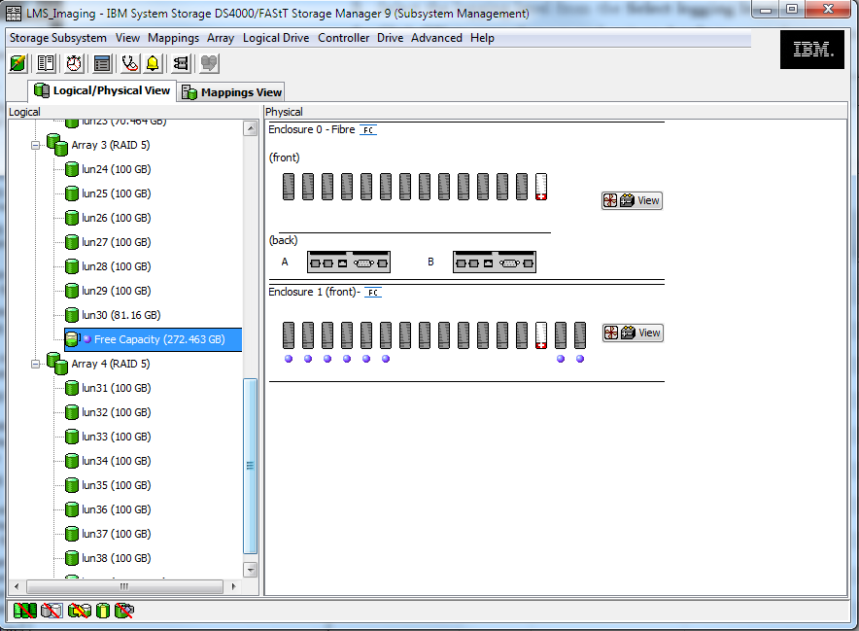

Create Logic Drive

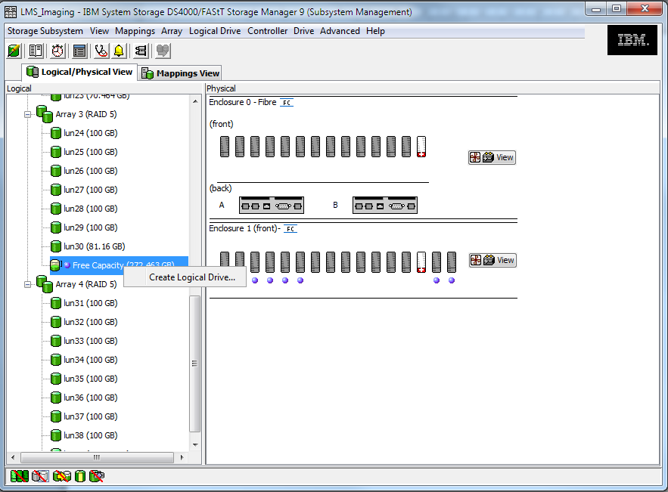

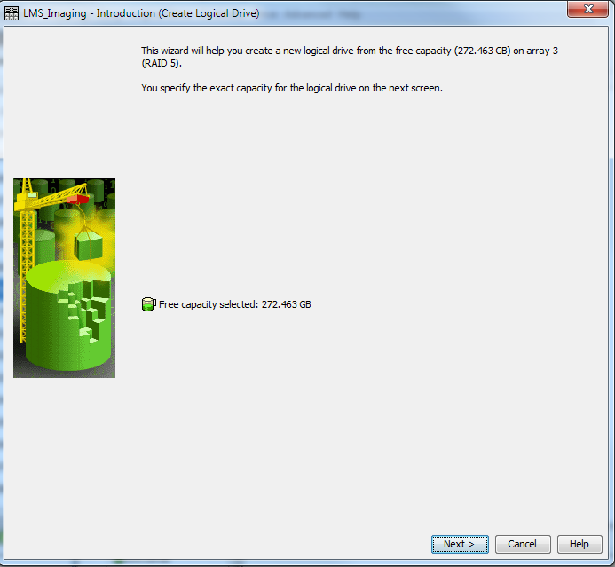

New Logic Drive capacity: 100GB, Name:lun40;

100GB, Name: lun41;

72.461GB, Name:lun42

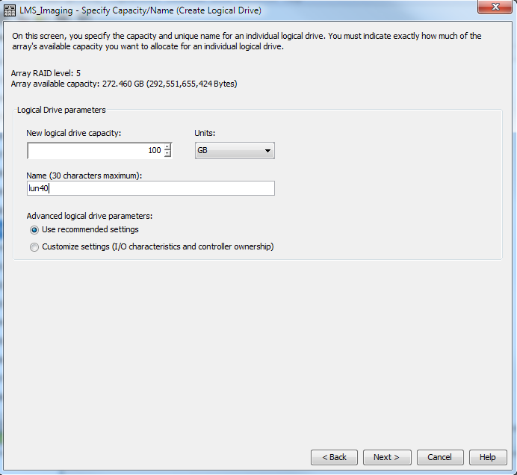

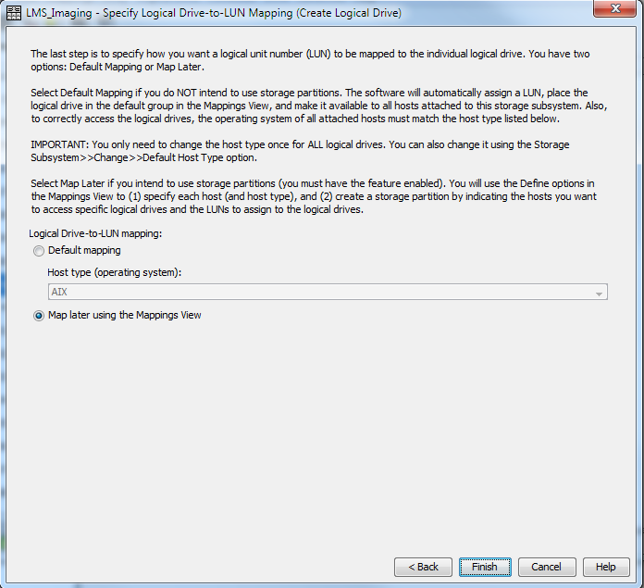

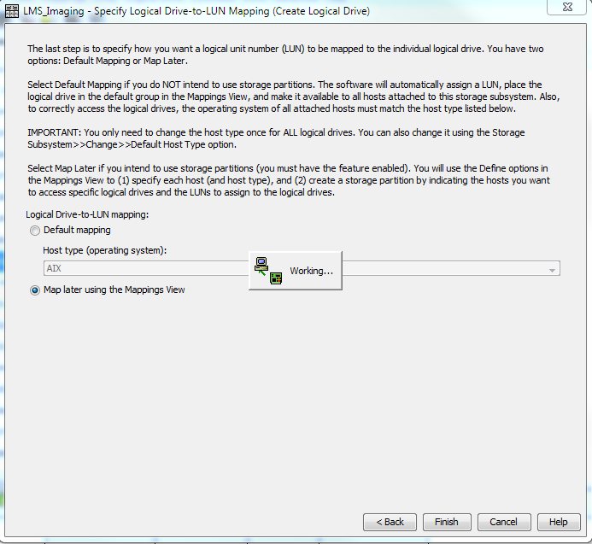

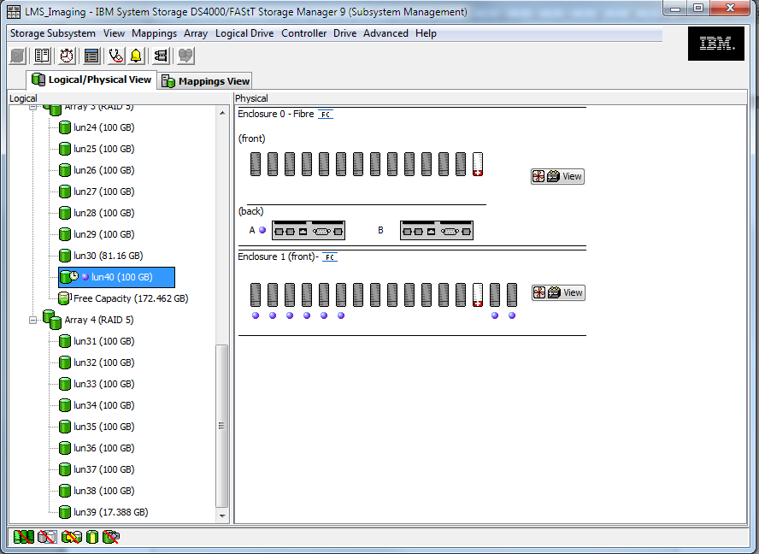

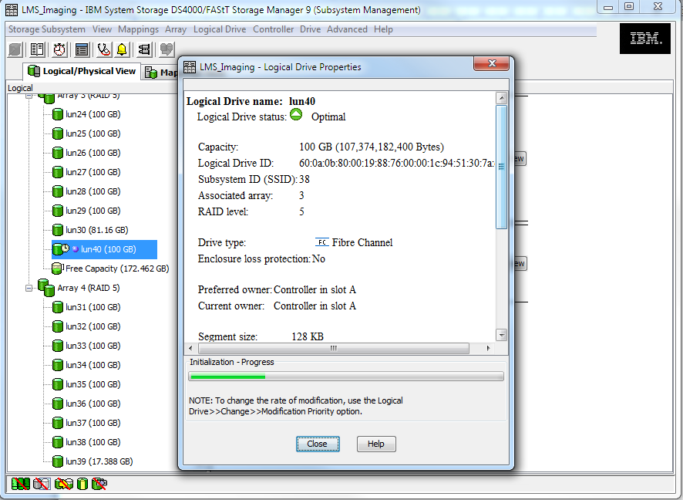

Define Additional Mapping, adds new created Logic Drives to Host Group: Adminserv_Imaging

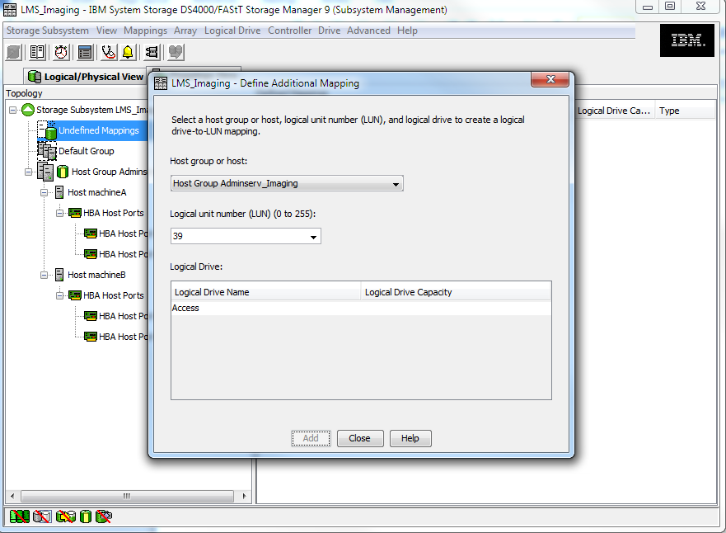

On Admsrv1 and Admsrv2:

# cfgmgr

# lspv

hdisk40 none None

hdisk41 none None

hdisk42 none None

# for i in 40 41 42

> do

> chdev -l hdisk$i -a pv=yes

> done

hdisk40 changed

hdisk41 changed

hdisk42 changed

# lspv

hdisk40 00ce35aa2788a941 None

hdisk41 00ce35aa278eb6e9 None

hdisk42 00ce35aa278eb896 None

After migrated to CGI, LMS servers (admsrv1/2) are logic partitions on IBM MODEL 8205-E6D(p740), PVs are assigned to LMS from HITASH storage via 2 vscsi(2/3) visual cards connected to 2 vios servers

root@admsrv1:/># lspv |grep None

hdisk58         00f86f6237c0f7f1                    None

root@admsrv1:/># lsattr -El hdisk58

PCM             PCM/friend/vscsi                 Path Control Module        False

algorithm       fail_over                        Algorithm                  True

hcheck_cmd      test_unit_rdy                    Health Check Command       True

hcheck_interval 20                               Health Check Interval      True

hcheck_mode     nonactive                        Health Check Mode          True

max_transfer    0x40000                          Maximum TRANSFER Size      True

pvid            00f86f6237c0f7f10000000000000000 Physical volume identifier False

queue_depth     8                                Queue DEPTH                True

reserve_policy  no_reserve                       Reserve Policy             True

root@admsrv1:/># chpath -l hdisk58 -p vscsi2 -a priority=2

path Changed

root@admsrv1:/># chpath -l hdisk58 -p vscsi3 -a priority=1

path Changed

root@admsrv2:/># lspv |grep None

hdisk58         00f86f6237c0f7f1                    None

root@admsrv2:/># lsattr -El hdisk58

PCM             PCM/friend/vscsi                 Path Control Module        False

algorithm       fail_over                        Algorithm                  True

hcheck_cmd      test_unit_rdy                    Health Check Command       True

hcheck_interval 20                               Health Check Interval      True

hcheck_mode     nonactive                        Health Check Mode          True

max_transfer    0x40000                          Maximum TRANSFER Size      True

pvid            00f86f6237c0f7f10000000000000000 Physical volume identifier False

queue_depth     8                                Queue DEPTH                True

reserve_policy  no_reserve                       Reserve Policy             True

root@admsrv2:/>#

root@admsrv2:/># chpath -l hdisk58 -p vscsi2 -a priority=2

path Changed

root@admsrv2:/># chpath -l hdisk58 -p vscsi3 -a priority=1